**Independent Sample T-Test**

The independent-samples t-test is used to assess whether the means of two independent groups statistically differ from each other. Through this test we would be able to check whether there is a correlation between the amounts of calories in cold cereals against the amounts of calories in hot cereals.

In order to conduct this test, a test of normality was carried out to check whether the dependent variable ‘Calories’ follows a normal distribution for both of the independent groups.

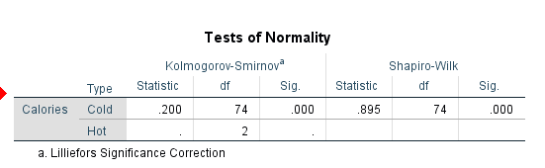

From the test carried out one can observe that the p-value (sig) is 0 < 0.05 therefore Calories is not normally distributed. Thus, since the dependent variable is not normally distributed, we decided to use the Mann-Whitney Test, which is an alternative of the Independent Sample T-Test, that assesses whether the medians of two independent groups statistically differ from each other.

**Mann-Whitney Test**

H0: The median amount of calories is the same for both groups.

H1: The median amount of calories is not the same for both groups.

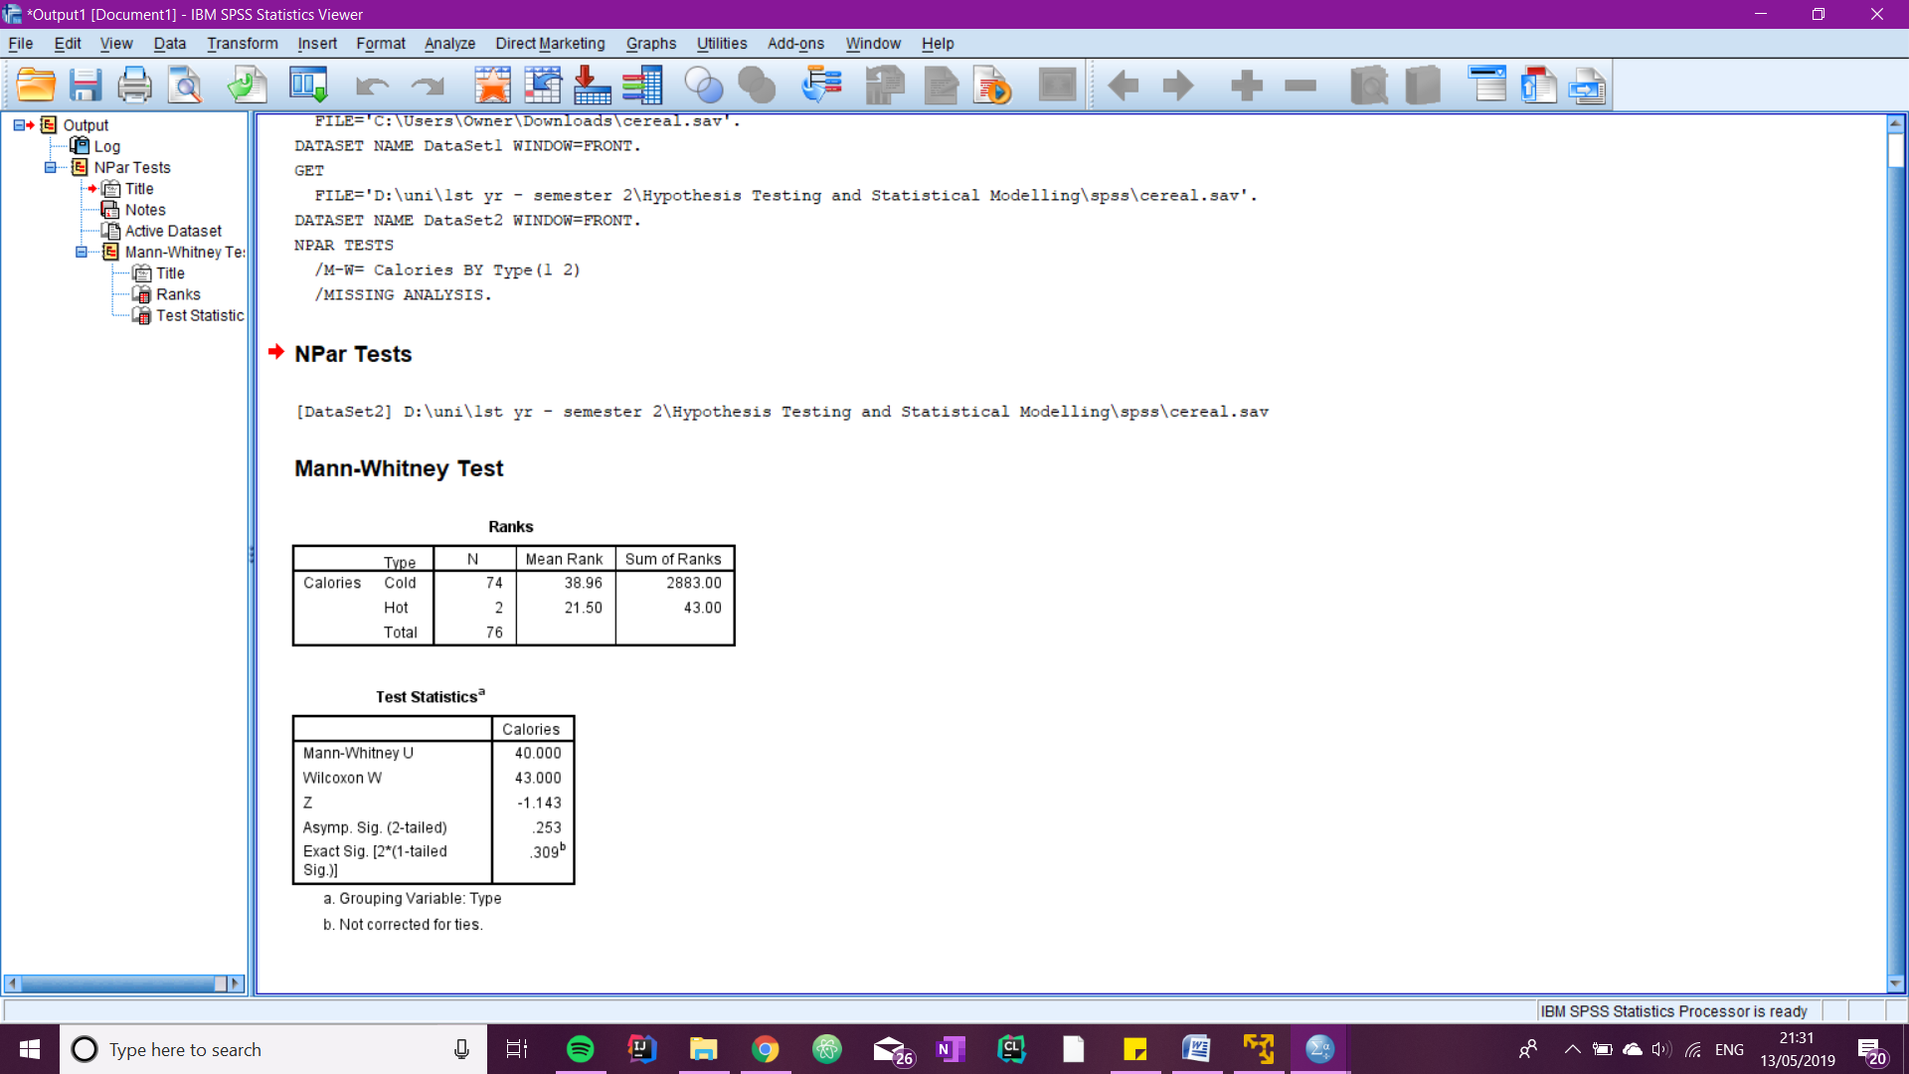

From this test one can notice that the p-value which is 0.253 is greater than the level of significance, therefore H0 cannot be rejected and we can state that the median amount of calories is the same for both groups. One can also observe that the group with the highest mean rank, in this case the cold cereals, contained a larger amount of calories.

<https://statistics.laerd.com/spss-tutorials/mann-whitney-u-test-using-spss-statistics-2.php>